Some feedback from the field
Natural convergence in the village

Name of the Village: Mandaragi cluster, Galaga gram panchayat.
Name of the Block: Devadurga taluk, Raichur district
Date: 10/01/2017
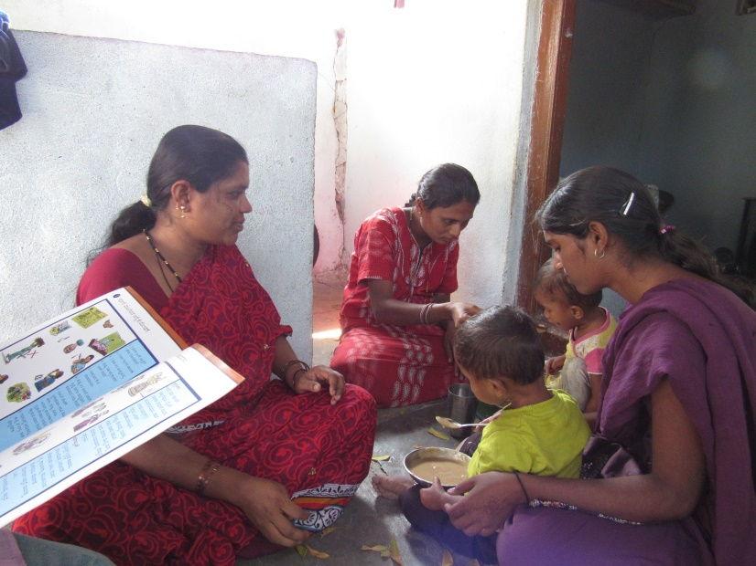

On 7th January, 2017 the first distribution of the Energy Dense Food (EDF) was initiated in Mandaragi cluster, Galaga gram panchayat Devadurga taluk, and Raichur district. Our Village Nutrition Volunteer (VNV) approached the beneficiary (17 month old young child) household to supply first EDF packet. The mother of the young child was a little reluctant because she assumed this food would not be of good quality
Village Nutrition Volunteer (VNV) and Anganwadi Worker guide complementary feeding of EDF to a child.

The rejection was not quite expected considering the fact that the Organization had made attempts to sensitize the beneficiary households in the village about the EDF, its use, its importance, composition and benefits to the child. At the same time, her neighbor who is an anganwadi worker saw our EDF packet and was delighted to approach us. She then explained about the importance of EDF to the mother recalling what she had learnt during the training provided as part of the ‘Karnataka Multi-Sectoral Nutrition Pilot Project’ by KHPT. She recalled that during the training she was oriented about the importance of nutrient dense food in the growth and brain development of children and that it is more or less equivalent to the commercial infant foods available in the market. As a result of the continued combined efforts of the anganwadi worker and our VNV to promote the importance of EDF, the consumption of the same has been consistent in this household.

Compiled by: Arundathi (Assistant supervisor)

The beginnings of behavior change

Name of the Village: Khasimbi of Koppar gram panchayat,
Name of the Block: Devadurga taluk of Raichur district
Date: 21/02/2017

Accepting EDF by the beneficiary household has not been an easy journey. Our VNVs are making relentless efforts in bringing about a behavior change in the villages despite the hardships. One such VNV is Khasimbi of Koppar gram panchayat, Devadurga taluk of Raichur district, who through her unfailing determination has brought about a change in a household which was prejudiced against EDF. In an incidence during the first round of distribution of EDF in her village, Jalambi, mother of 29 month old young child named Ranjanabhi expected something else instead of the EDF packet. Her expectations were to receive pulses, cereals, nuts and jiggery and she was definitely not pleased seeing the ready to cook food product. It is quite expected to face such a reaction owing to the financial status of the family. The household comprises of 8 members including Jalambi and her husband, 2 children, Jalambi’s father-in-law, mother-in-law and 2 sisters-in-law. Jalambi’s husband is the bread winner and is an unskilled manual day laborer and the family is in extreme poverty.
VNV accompanied by the another VNV of same village (to her right) measuring the MUAC of the beneficiary and involving the family in behavior change Communication
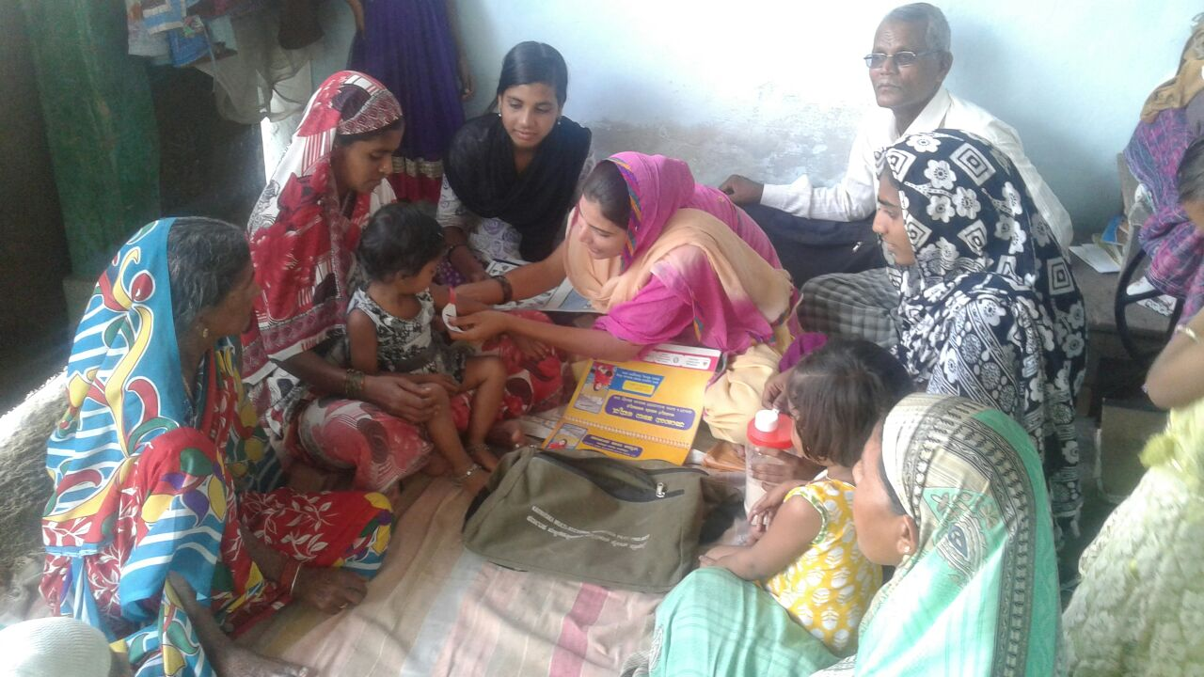
Our VNV was quite terrified by the way Jalambi spoke to her but did not lose hope and she gathered courage instantly and counselled her about the importance of EDF. She convinced her saying the EDF contains all the necessary pulses and cereals required to promote adequate growth of the child and read out the composition of the food product and how each ingredient helps in growth and development of her child. The importance for adequate weight and height for age was also explained. After a long conversation, Jalambi was quite convinced and agreed to feed her child with EDF; after which the VNV demonstrated the process of mixing the EDF and fed it to the mother and she acknowledged that it tastes good.
Although during the previous visit, Jalambi seemed convinced, the second time when our VNV visited post 10 days for second round of distribution, the situation was quite different. The child was suffering with diarrhea and on seeing the VNV, Jalambi started humiliating her making claim that it is because of the EDF the child is suffering from diarrhea. Jalambi also started demanding money for treating the child and made her feel guilty for giving the food packet. The VNV was taken aback and did not know what should be done in that situation. Although VNV knew that the reason for diarrhea was due to lack of hygiene and sanitation and not EDF, however at that point of time she could not face the fury of the family. Then she approached another VNV (Alia) working in the same village to seek her support in tackling the issue. Together they approached the household and gathered the entire family to counsel about the importance of hygiene and sanitation using the communication materials. They also explained that what the immediate treatment to be given during diarrhea is preparation of ORS. The demonstration of preparation of ORS at home was provided and the importance of hygiene during preparation was highlighted. The mother was convinced and started feeding the child with ORS as indicated. Next day VNV visited the house and was pleased to see that the child had lesser frequency of diarrhea. After seeing the improved status of the child, VNV again reiterated the importance of EDF and how it can be prepared in different forms and fed to the child.
Few days later (10 days) when the VNV paid her regular visit she was surprised and overwhelmed by the treatment given to her by the household members. She was delighted to hear that the child is regularly eating the EDF and family is also positive towards feeding the child. The child’s mother and other members of the family apologized for their previous behavior towards her. VNV Khasimbi felt satisfied that her relentless efforts paid off and uses the example of this household to convince others in the village.
Compiled by: Khasimbi (VNV)

One life saved!

Name of the Village: Hirebudur gram panchayat
Name of the Block: Devadurga taluk, Raichur district
Date: 21/02/2017

Often a woman neglects her own health prioritizing her family’s health. Shantamma, one of our beneficiaries was registered with the project when she was 7 months pregnant. At the time of registration we found that she was anemic (Hb: 7g/dL) and she weighed only 40.0 Kg. Gangamma, the project VNV for Hirebudur gram panchayat during registration found out that Shantamma lost 3 children owing to nutritional deficiency and poor health.
Understanding the previous obstetric history and her present condition, our VNV devoted most of her time in repeated visits to her house to make sure her health improved and did not want this child to be lost. Gangamma through her repeated visits would make sure she consumed the IFA tablets regularly and by counselling her to consume nutritious food and reduce the work load. But Gangamma was frustrated after a point and asked the VNV not to visit frequently and since she is poor she cannot do anything about the situation.
A month later when our central team visited that village, we noticed that Shantamma was suffering with diarrhea and was severely dehydrated, yet she continued to perform strenuous labor. During our interaction with her she revealed that the physician had warned that she might lose the child since she is severely anemic but her family did not bother about improving her health. Our VNV was deeply moved and she did not refrain from lending her all possible help she could to save the mother and child. Few days later she consulted our project supervisor and with her help along with ASHA and Junior Health Assistant (JHA) they got Shantamma admitted in Raichur Institute for Medical Science, a Government hospital in Raichur district. At the hospital she was treated for anemia and her hemoglobin level reached 11.0g/dL. Finally she delivered a 2.75Kg infant on 20th September, 2016. Both the mother and child were in good condition.
The entire family rejoiced and the entire team was very delighted that they could save a child. The family members were very pleased by the efforts of the VNV that they mentioned they would have named their child as Gangamma if it was a female child. Shantamma fed the infant colostrum and is still breastfeeding along with initiation of complementary food from 6 months. All in all the combined efforts of members from different sectors together could save the life of a mother and child.
Compiled by: Rekha (Supervisor)

A Success story
Name of the Village: Marakandinni gram panchayat
Name of the Block: Devadurga taluk, Raichur district
Date: 02/02/2017

The nutrition card mirrors the nutritional status of the beneficiary. The VNVs fill the nutrition card every month and based on the details take necessary action if required and plan their counselling for the household. Likewise in the month of September, 2016 during filling of the nutrition card it was noticed that a child named Ajith was severely malnourished (MUAC: 11cm) and also suffering with diarrhea. The child weighed 6.0 Kg and the height was 75 cm. The VNV of the village named Marakandinni gram panchayat of Devadurga taluk, Raichur district intimated the project supervisor and together they visited the household for counselling and guidance. After providing them with appropriate guidance and explaining the severity of the situation, the family members took the child to Basavalingappa hospital in Sirivar, a neighboring district. On reaching the hospital the doctors realized that the child was dehydrated and they administered saline and was under observation for a few days and later discharged. Once the child was back home, the VNV along with anganwadi worker paid regular visits to the household to see the child was improving. The anganwadi worker along with close monitoring made sure the child gets egg and other supplementary foods provided as part of the ICDS. Our VNV counselled them about the importance of hygiene and sanitation and the role of complementary feeding. It is noted that the child now weighs 10 Kg and the MUAC is 14 cm which indicates that the child is now normal. The family is very pleased by the care and concern of the VNV as well as the timely response to the child’s condition.

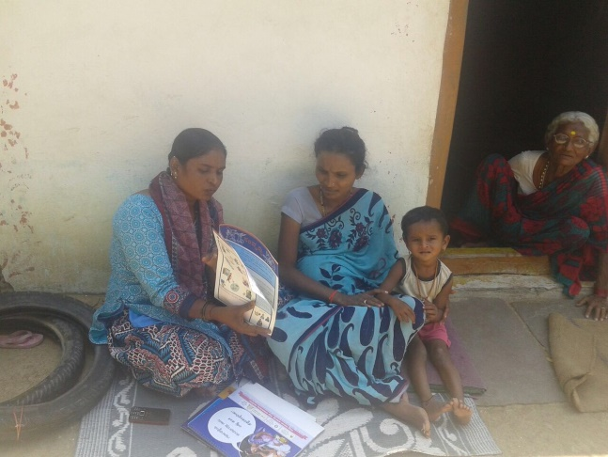

VNV counselling mother of ajith who is pregnant
Compiled by: Padmavathi (Supervisor)

How do we solve this problem?

Name of the Village: Jalahalli cluster, Yaragudda gram panchayat
Name of the block: Devadurga taluk, Raichur district
Date: 02/02/2016
Dyavamma, is a mother of five children of which two are our beneficiaries; one is an adolescent girl and another is an infant by name Kariappa (Ranganath). The adolescent girl is 13 years old and is physically challenged. Dyavamma has delivered all her children at home except the last child, Kariappa. The institutional delivery was as a result of repeated persuasion of VNV and anganwadi worker of Jalahalli cluster, Yaragudda gram panchayat.

The child weighed 2.0 Kg when born (5-09-2016) and the doctors advised that the child needs to be taken to the district hospital but the parents refused and brought the child home. The mother did not consider it important to take care of the child despite being advised about Kangaroo Mother Care. With relentless efforts of the VNV the child received the immunization as per the schedule. It was noticed that the child’s weight was 2.7 Kg after a month and half after birth and was weak.

The VNV on noticing the condition of the child informed the anganwadi worker and the child was referred to RIMS hospital, Raichur district. The child was admitted for a month and showed little improvement and the treating doctors asked the mother to stay for 3 months for the child to recover completely. But the mother said she cannot stay for long since she has to take care of 4 other children and has to be back home and took back the child.

Next month as her routine when VNV went to measure height and weight of the child, she noticed that the child was very weak and again convinced the mother to take back the child to hospital with the help of Anaganwadi worker. The mother returned back with the child staying there for 15 days since her household responsibility vested with her. Both VNV and anganwadi worker were in a helpless situation and did not know what could be done. The mothers point was valid since she had to cook and take care of other children too and she did not get any support from any family member. The mother finally lost hope on saving the child and she was helpless too. The child expired a month later and the mother grieved that she could not save the child.

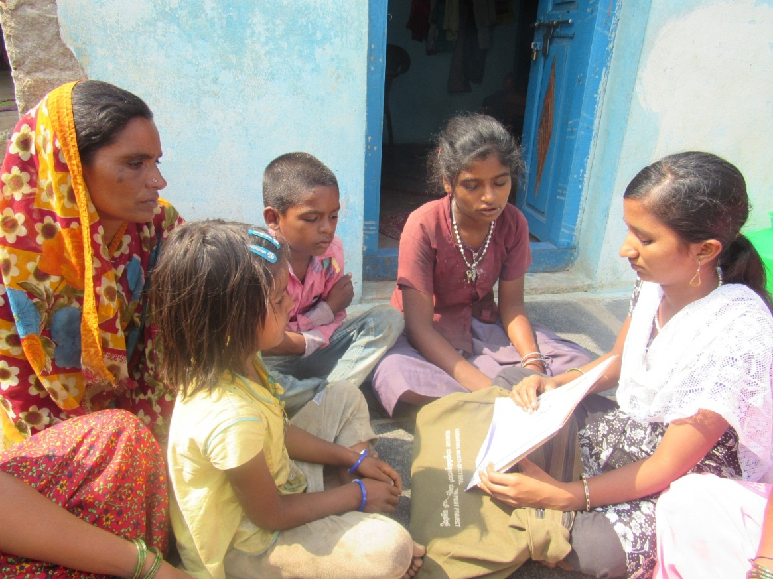

VNV counselling Dyavamma with her three children; the adolescent girl is physically challenged.

The situation could have been better if there was a facility within the village where the mother could stay in the village, take care of the child and other children as well.

Compiled by: Hanumanthi (VNV)

